**Lab 10**

1. **[3] Write and execute a T-SQL stored procedure *Factorial*(*n*), which computes and outputs the factorial of the input parameter *n*.  If *n* is negative, then the procedure prints an error message.**

Attach the screenshots of the output and the command which you used to execute the SP.

 Ans:-

Alter procedure getFactorial(@number int)

as

begin

set nocount on

Declare @fact int = 1,

@result int=1

if(@number<0)

print 'no negative value is alowed';

else

begin

while (@fact<=@number)

Begin

Set @result = @result * @fact

Set @fact += 1

End

Select convert(varchar,@number)+'!='+convert(varchar,@result)

end

End

exec getFactorial 5;

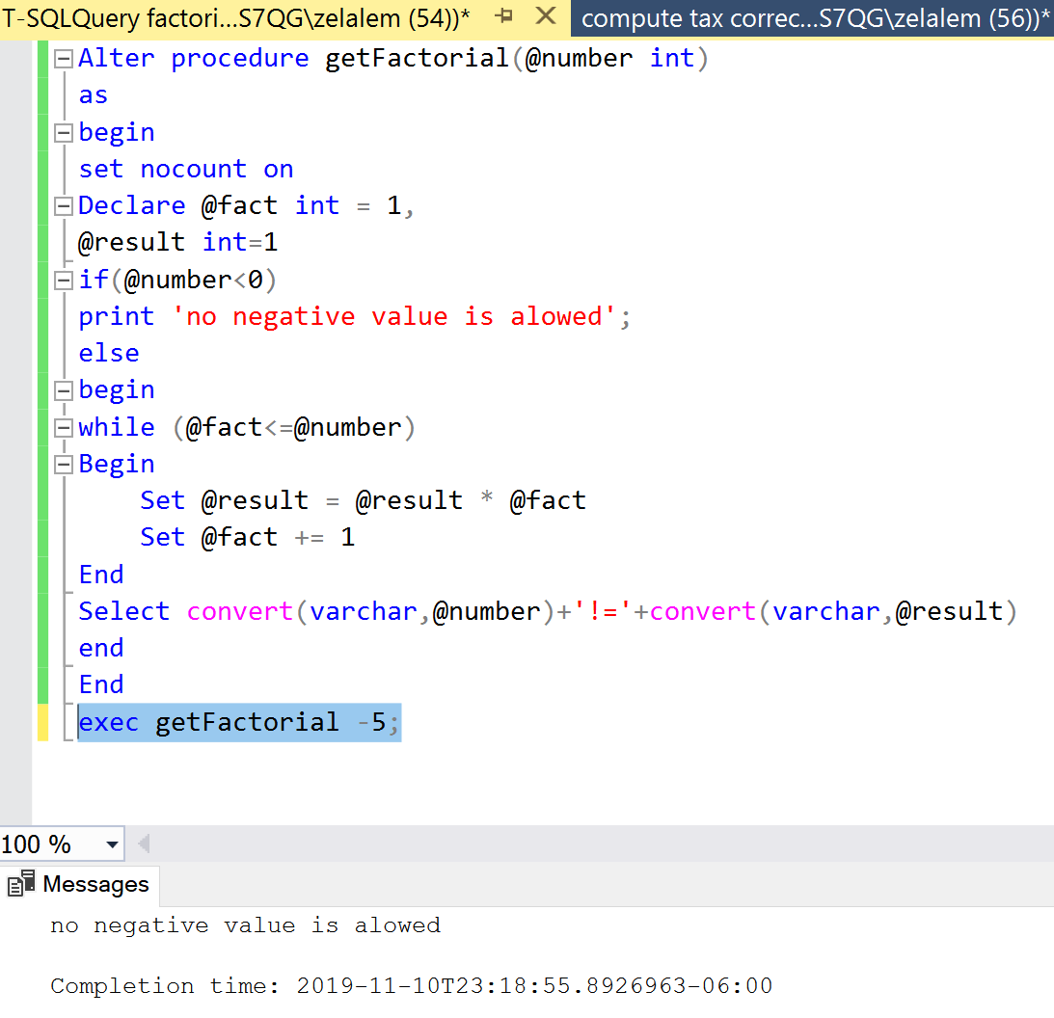

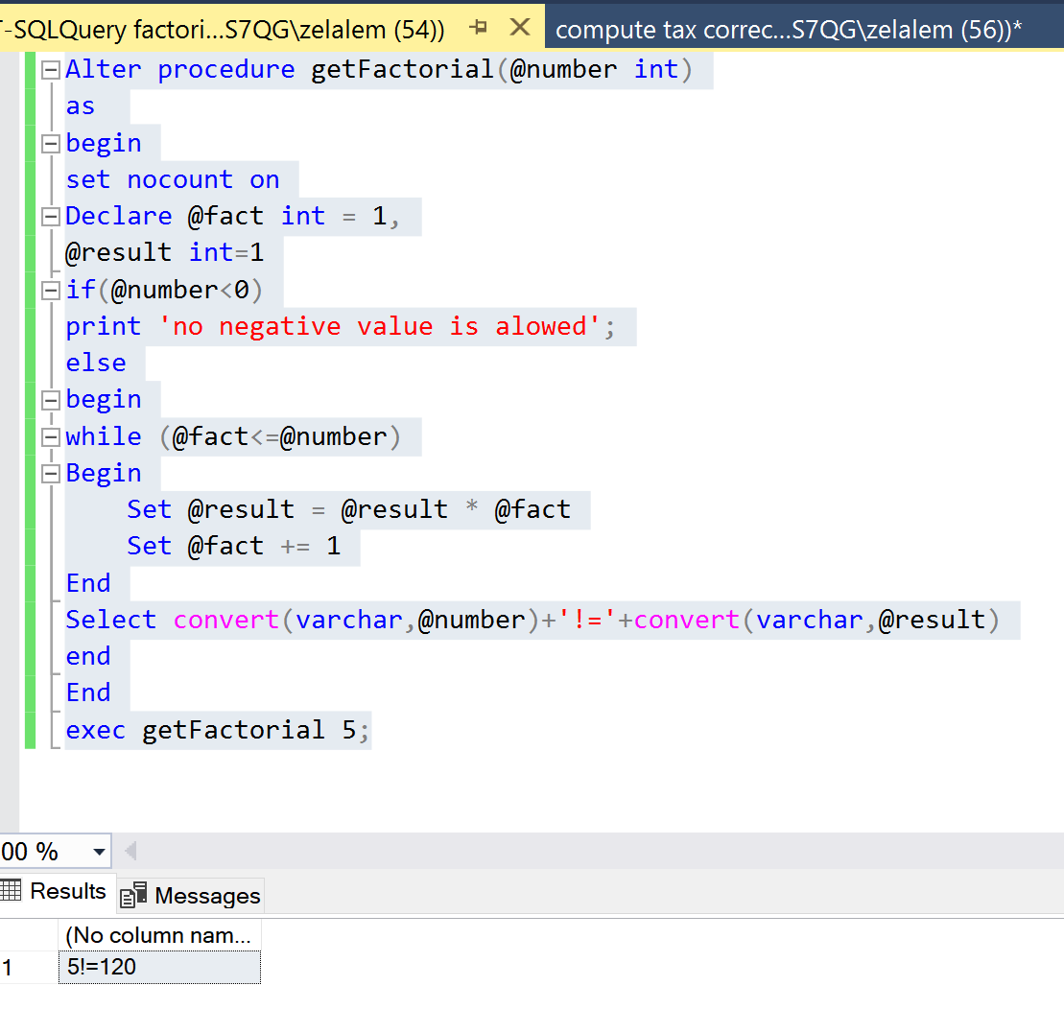

1. **[7] Create a Table *Employee* with the fields:  social security no. (primary key), name, position, no. of dependents, annual salary.**

**Write and execute a T-SQL procedure *Compute_Tax* to do the following:**

* **Create a new table *Tax* with fields:  social security no., income tax.**
* **Fill the table *Tax* with data by computing the income tax for each person in the Employee Table.**

The income tax is computed from the annual salary S and the number of dependents D.

Net Salary:  S - (7000 + D*950)

Tax Computed as follows:

* 10% of the first 15,000 of net salary;
* plus 15% of the next 15,000 of net salary;
* plus 28% of any net salary over 30,000.

For getting full credit for this problem, you need to show the complete code for the *Compute_Tax* SP.  Also attach the screenshots of the *Employee* and the new *Tax* table.

**Ans:**

USE CS422

SET ANSI_NULLS ON

GO

ALTER procedure Compute_Tax

AS

BEGIN

create table Tax(SSN varchar(20),

IncomeTax decimal)

INSERT INTO Tax

SELECT empl.SSN,

(CASE WHEN empl.netsalary>=15000

THEN 0.1*15000

ELSE

0.1*empl.netsalary

END +

CASE WHEN empl.netsalary>=30000

THEN 0.15*15000

ELSE

CASE WHEN empl.netsalary>=15000

THEN 0.15*(empl.netsalary-15000)

ELSE 0 end END +

CASE WHEN empl.netsalary>=30000

THEN 0.28*(empl.netsalary-30000)

ELSE 0 END )

AS IncomeTax from (select ssn ,(anualSalary-(7000+dependents*950)) as netSalary from dbo.Employee) AS empl;

END

select * from Tax;

Employee table

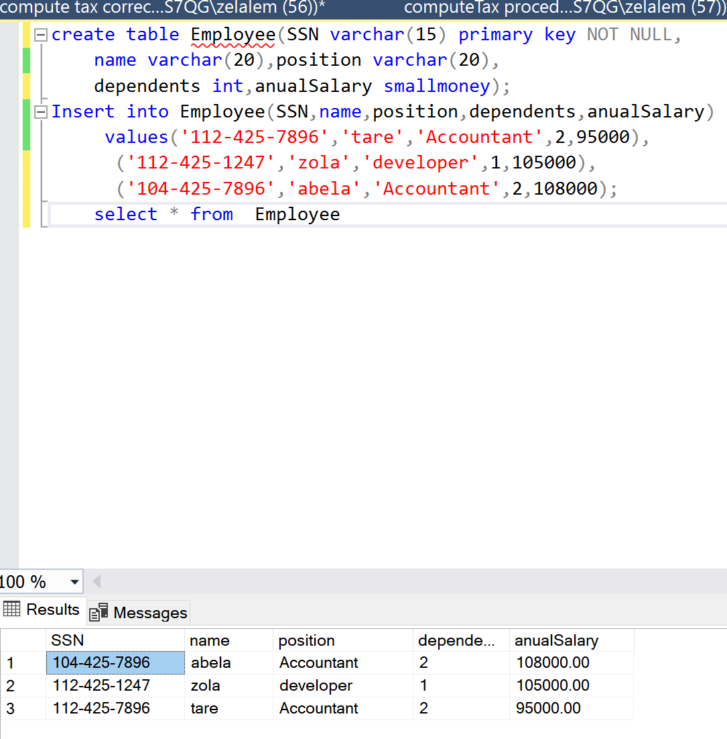

Compute_tax store procedure  
